Introduction to the
Your Spending Account™
(YSA^{™)} Website
SYSCO
October 17, 2016

Table of Contents
Account Summary 4
Submitting a Health Care FSA or Health Reimbursement Account Claim 5
Submitting a Dependent Day Care Flexible Spending Account Claim 9
Substantiating an Existing Claim 13
Using Your YSA™ Card—Save Your Receipts! 19

Your Spending Account™ (YSA™) website – an Ongoing Resource
The YSA™ website makes spending account transactions easy. Take a look at this brief overview to help you understand the features available to you and the steps you need to take.

You may access the YSA™ website through a link on the Total Rewards Cafe™. To access the Total Rewards Cafe™, you can login:

- Through Sysco Benefits at www.syscobenefits.com, available from the Sysco intranet and the Internet; or
- Directly to http://resources.hewitt.com/sysco using your Total Rewards Cafe™ user ID and password. You can access your user information from the Total Rewards Cafe™ logon page or create a user ID and password by clicking on “Generate your user ID and password here.”
After you have logged on to the Total Rewards Cafe™ site, you can select the account type that you want to view. This could include “Health Care Flexible Spending Account”, ”Health Reimbursement Account’’ or “Dependent Day Care Spending Account” from the tiles on the home page. If you have a Limited Use FSA, you will access it by selecting “Health Care Flexible Spending Account.”

When you are enrolled in the Health Care Spending Account (HCSA), Limited Use Flexible Spending Account (LUFSA), and/or Dependent Day Care Flexible Spending Account (DDCFSA), and visit the YSA™ website, you will be able to:
- Submit claims and review their status;
- Access a list of eligible expenses and approved merchants;
- Learn why submitted claims may need your follow-up and what to do about it; and
- View your current account balance(s).

Continue reading to see images of the YSA™ pages that you will use to manage your spending account(s).

Account Summary
From the Account Summary page, you have access to:
- Recent Activity - View your 20 most recent claims, the last 15 payments that have been issued, and the last 12 months of documents submitted to YSA™
- Take Action - submit claims, check eligible expenses
- Knowledge Center - Helpful tips on documentation requirements
- Your Profile - Add or remove direct deposit
- Secure Mailbox - Allows you to ask account specific questions and receive answers without having to call the service center
- View your Account Balances – View your current account balances

Submitting a Health Care FSA or Health Reimbursement Account Claim
You can choose to pay out-of-pocket for eligible expenses and submit a claim to YSA™, rather than using your YSA™ Card at your medical or dental provider’s office or when purchasing certain health care items or prescriptions. Claims should be submitted using one of the methods below:
- YSA’s mobile app Reimburse Me
- Online using the instructions below, or
- Paper claim using the instructions on the form

(Important: Do not use your YSA™ Card and submit an online, paper or mobile app claim for the same expense. This will delay processing of your claim.)

Follow these steps to submit an online claim from this page:
Note: The Health Care FSA form is also used for the Limited Purpose Health Care FSA.
- Select the appropriate account from the Total Rewards Cafe™ page—Health Care FSA, Limited Purpose FSA or Health Reimbursement Account (Image A);
- Select “Create Health Care Claims” on the right side of the page (Image A);

IMAGE A
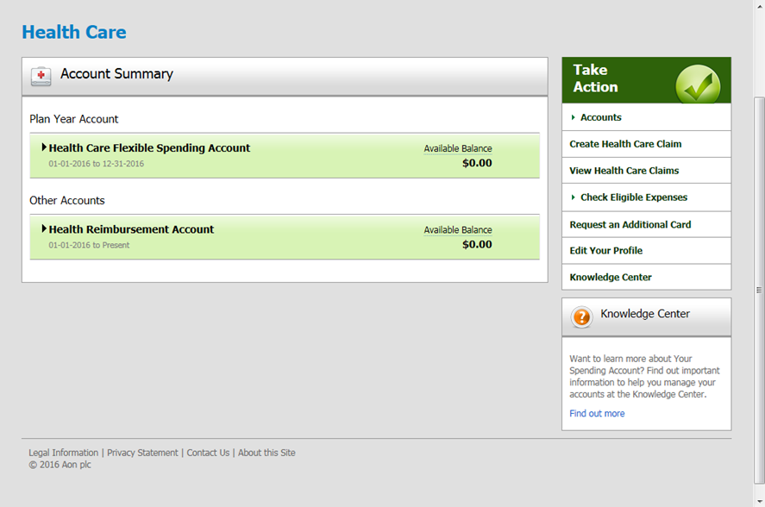

- Choose How to Send Your Receipts or Documentation, either via Upload or Fax/Mail (Image B);

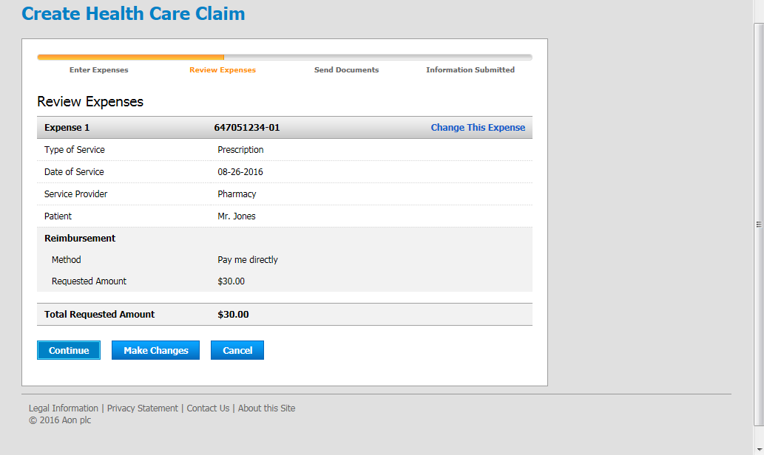
IMAGE B
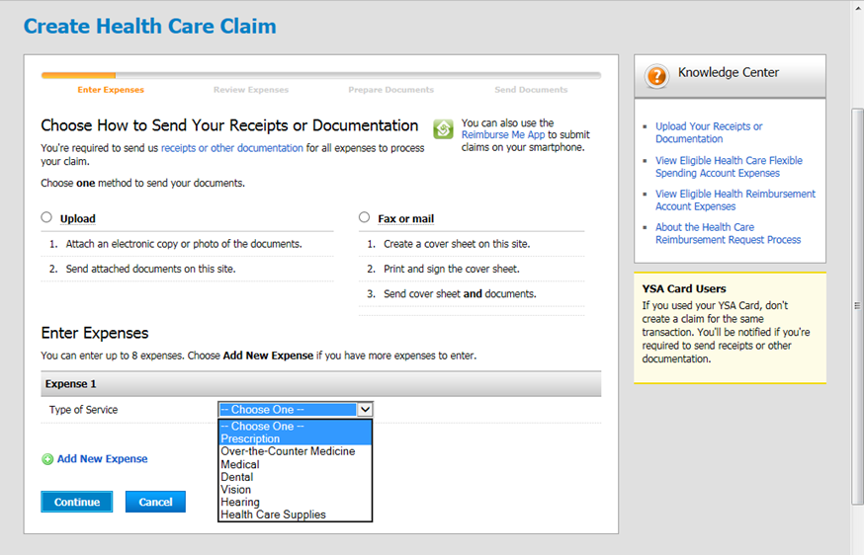

- Enter your claim detail information (Image C);

IMAGE C
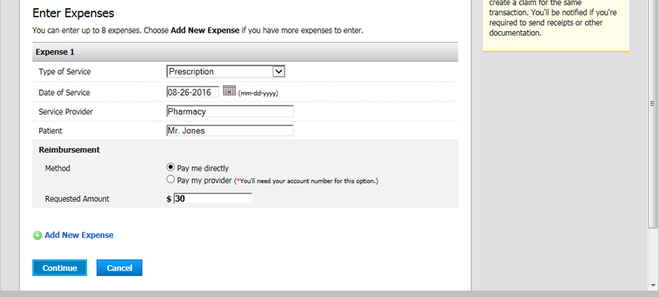

- Select “Continue” at the bottom of the page;
- Review Expenses (Image D)
- Make changes if necessary
- Select “Continue” at the bottom of the page.

IMAGE D
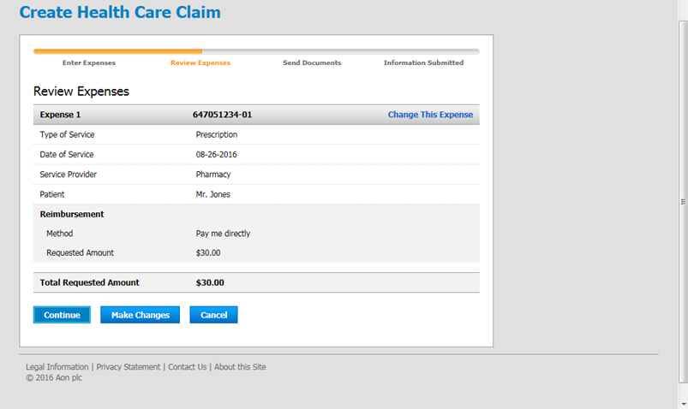

- Upload your document (Image E) or Create Fax Cover Sheet (Image F). A fax cover sheet is required only if you do not choose to upload the documentation when you create your claim during this step.

IMAGE E
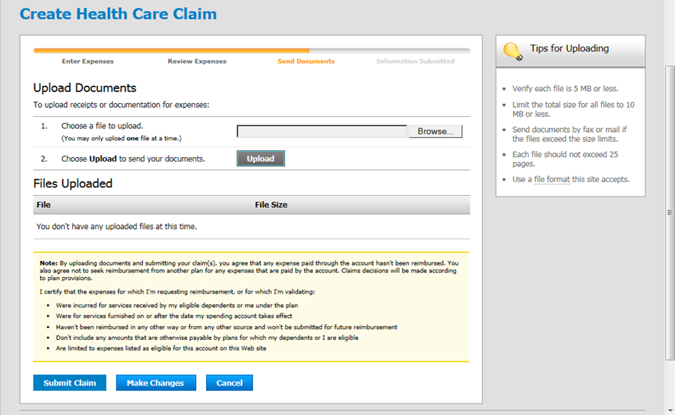

IMAGE F
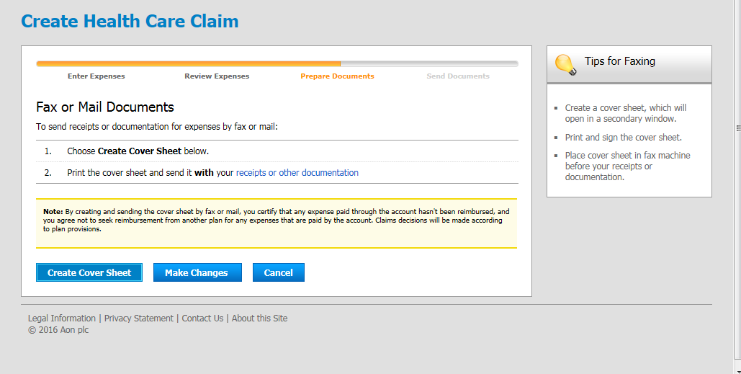

- Fax the claim form and receipt(s) to Your Spending Account™ at 1-888-211-9900.

Submitting a Dependent Day Care Flexible Spending Account Claim
You are required to pay out-of-pocket for eligible expenses and then submit a claim to YSA™ for reimbursement. Claims should be submitted using one of the methods below:
- YSA’s mobile app Reimburse Me, or
- Paper claim following the instructions on the form

All claim forms are available on the YSA website or you may contact the YSA Service Center at 800-55-SYSCO. Be sure to include itemized receipts with all submitted claims.

Follow these steps to submit an online claim from this page:
- Select Dependent Care account from the Total Rewards Cafe™ page;
- Select “Create Dependent Care Claims” on the right side of the page (Image A);

IMAGE A
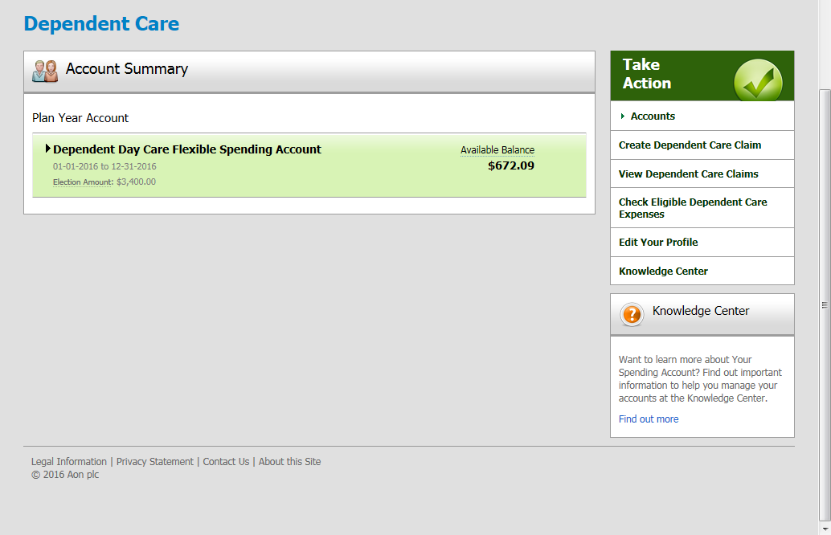

- Choose How to Send Your Receipts or Documentation (Image B);
- Enter your claim detail information (Image B);
- Select “Continue” at the bottom of the page;

IMAGE B
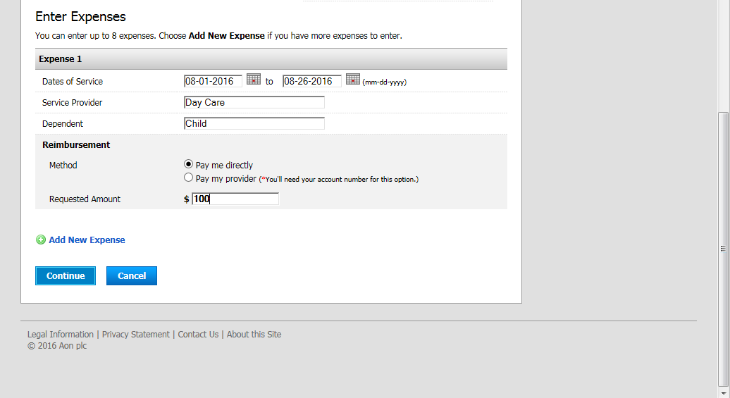
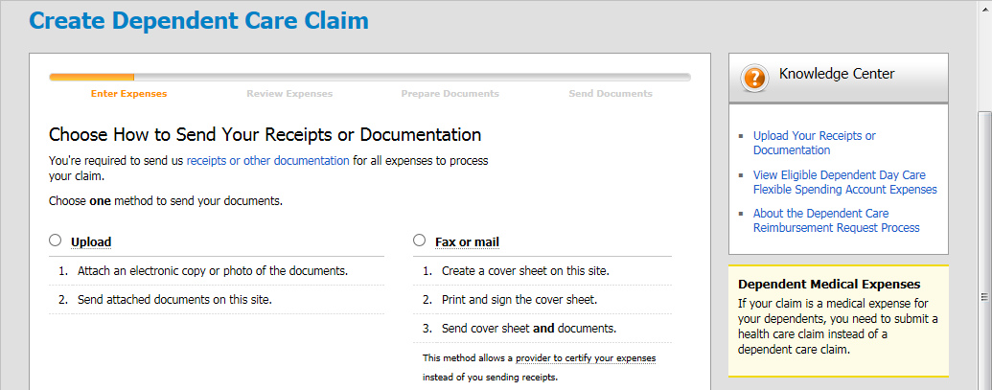

- Review Expenses (Image C)
- Make changes if necessary

IMAGE C
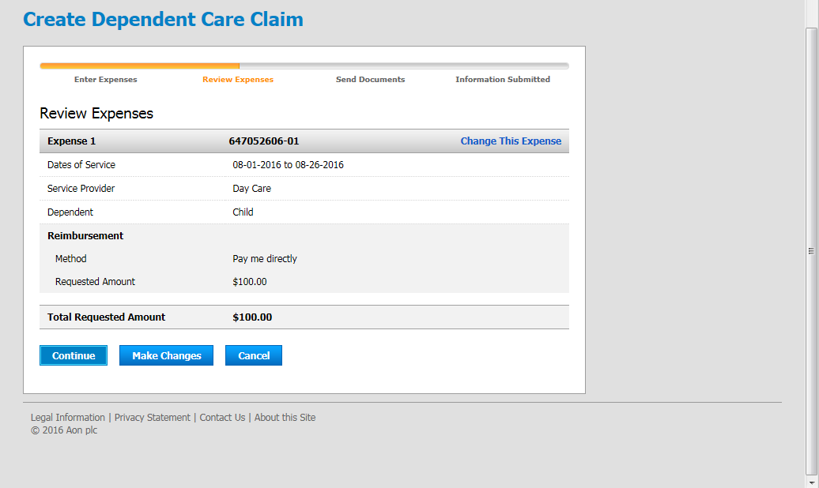

- Select “Continue” at the bottom of the page
- Upload your document (Image D) or Create Fax Cover Sheet (Image E). A fax cover sheet is required only if you do not choose to upload the documentation when you create your claim during this step.

IMAGE D
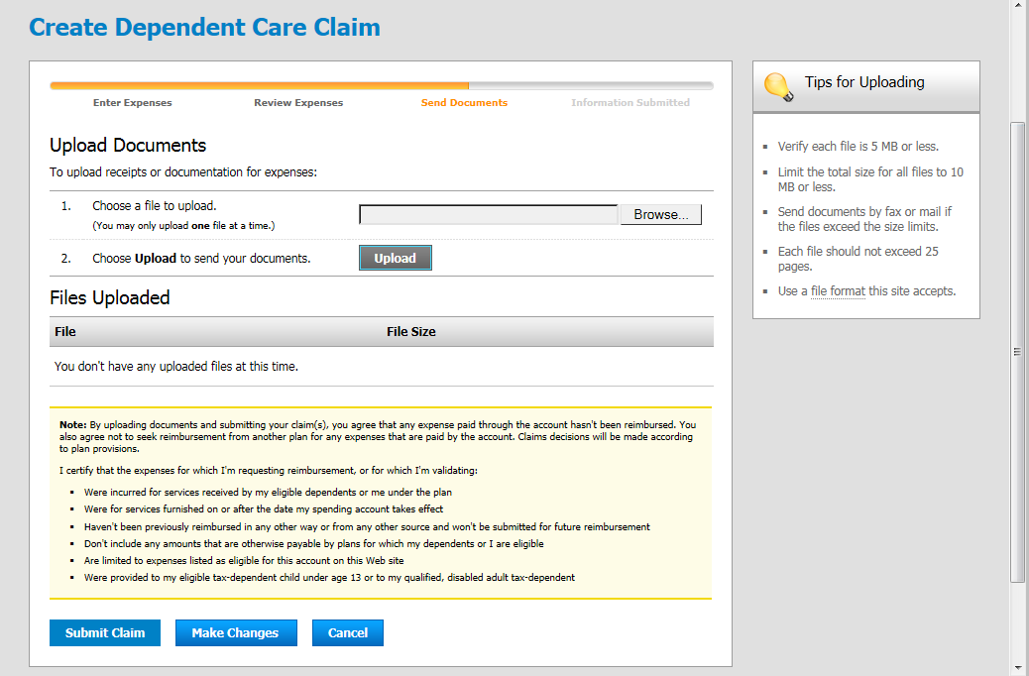

IMAGE E
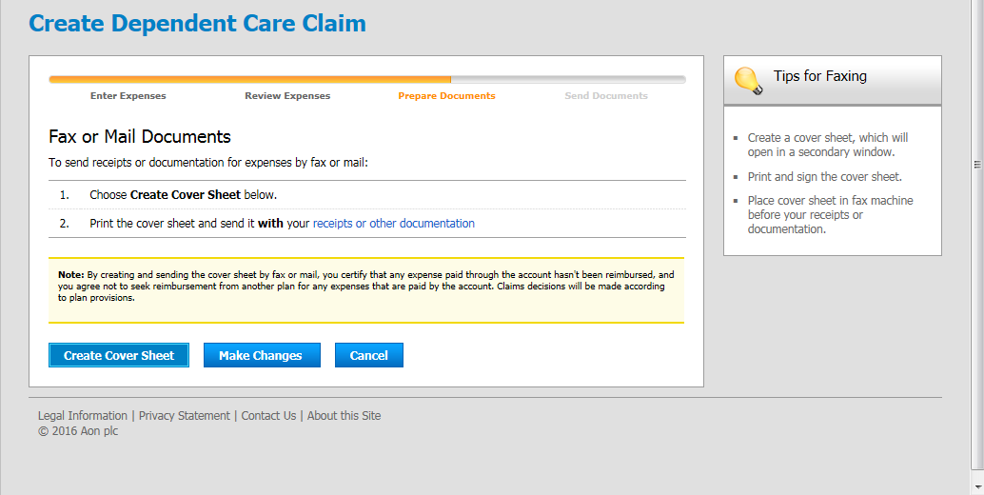
- Fax the claim form and receipt(s) to Your Spending Account™ at 1-888-211-9900.

Substantiating an Existing Claim
The YSA Card is one of the most valuable features of a health spending account. Each time your card is used, your account is automatically debited for the eligible expense. Although the card swipe is conditionally approved at the time of purchase, you may still be asked to provide receipts to substantiate (verify) that a purchase is eligible. Documentation must be received within the allowed timeline or the claim could be denied and become an overpayment. For continued processing of your claim, you will be required to provide the supporting documentation.
Follow these steps to substantiate a claim that is not in Overpayment:
- Select the appropriate account from the Total Rewards Cafe™ page—Health Care FSA, Limited Purpose FSA, or Health Reimbursement Account:
- Select “Receipt Due By [Date]” highlighted link (Image A);

IMAGE A
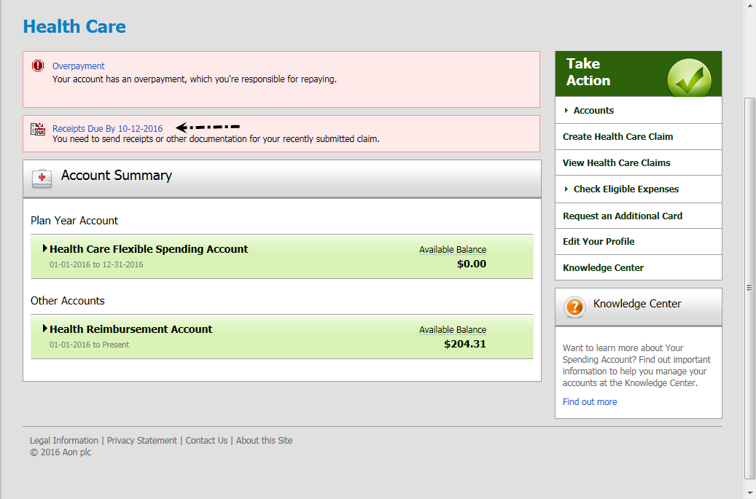

- Choose How to Send Your Receipts or Documentation, either via Upload or Fax/Mail (Image B);

IMAGE B
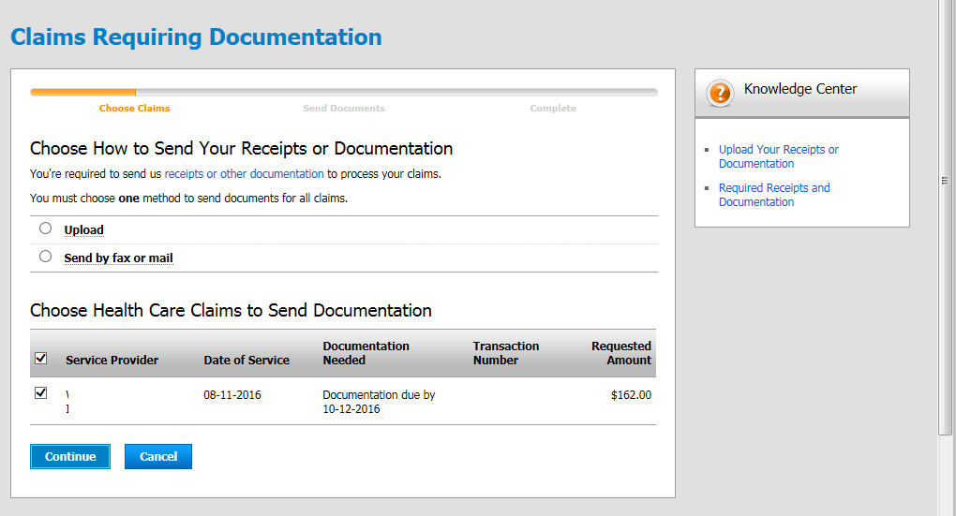

- Select “Continue” at the bottom of the page (Image B);
- Review Expenses
- Make changes if necessary
- Select “Continue” at the bottom of the page;
- Upload your document or Create Fax Cover Sheet;
- Fax the claim form and receipt(s) to Your Spending Account™ at 1-888-211-9900.

Follow these steps to substantiate an existing claim that is in Overpayment:
[Please note that you may choose to repay the overpayment via online direct deposit or by mailing a check]
- Select the appropriate account from the Total Rewards Cafe™ page—Health Care FSA, Limited Purpose FSA, or Health Reimbursement Account:
- Select “Overpayment” highlighted link (Image A);

IMAGE A

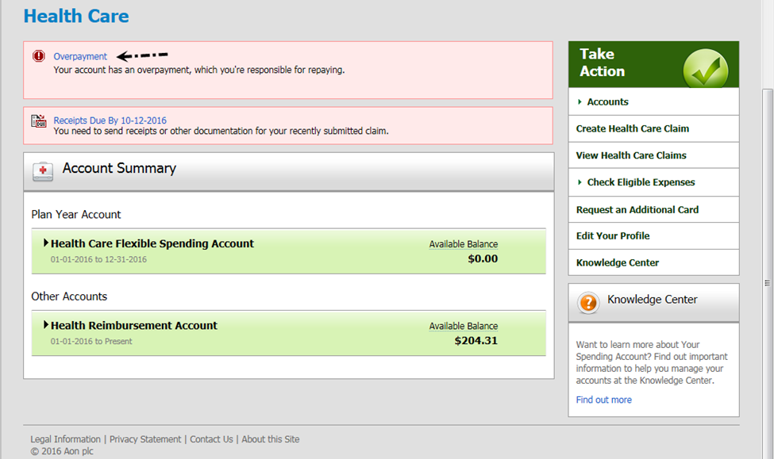

- Under details of the overpayment, select the Claim number (Image B):

IMAGE B
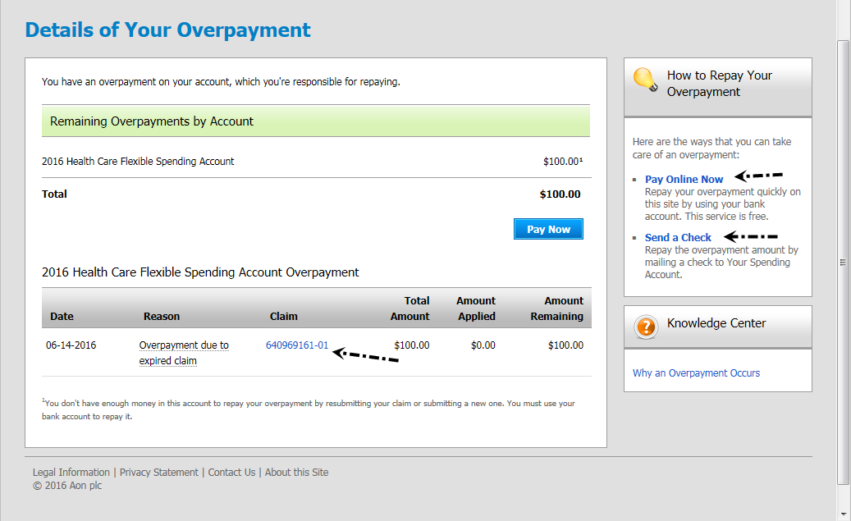

- Select “Resubmit” at the bottom of the page(Image C):

IMAGE C
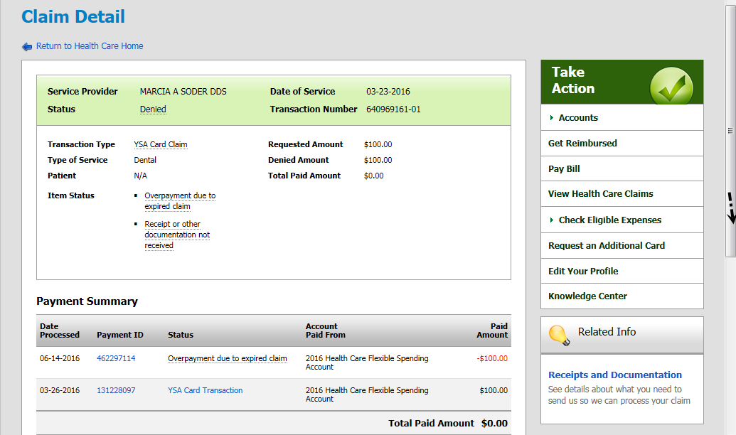
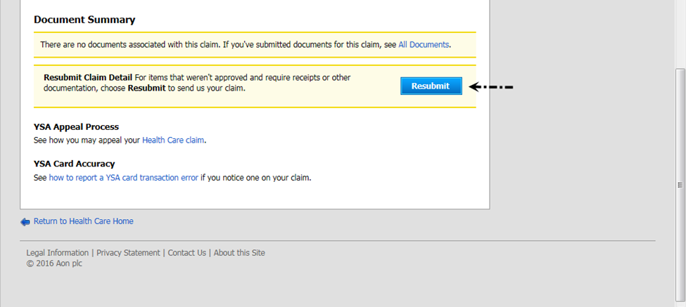

- Choose How to Send Your Receipts or Documentation, either via Upload or Fax/Mail (Image D);
- Select “Continue” at the bottom of the page(Image D);

IMAGE D

- Review Expenses
- Make changes if necessary
- Select “Continue” at the bottom of the page;
- Upload your document or Create Cover Sheet;
- Fax the claim form and receipt(s) to Your Spending Account™ at 1-888-211-9900.

Using Your YSA™ Card – Save Your Receipts!
If your preference is to use the YSA™ Card, you will be able to pay for most eligible HCFSA expenses by simply swiping your card at the point of purchase.
Note: Use the YSA Card only for expenses incurred during the current plan year. The YSA™ Card is available for the HCFSA and HRA plans only. You will need to file a claim for any expenses for which you do not use your YSA™ Card, including prior year expenses. You can submit an online claim on the YSA™ website or via the YSA Mobile App.
Each time you “swipe” your YSA™ Card, be sure to save your itemized receipt(s) in case you are required at a later date to substantiate that your expense was eligible for reimbursement under the Plan. Per IRS rules, unsubstantiated expenses will be considered taxable income.
When Your Spending Account™ is unable to automatically substantiate a transaction, a request for documentation is sent to you. An email will be sent shortly after the transaction has been loaded to the YSA™ website. The YSA™ Card transaction can be viewed within two to three business days. The YSA™ website will display the 30-day deadline for YSA™ to receive needed documentation. If you provide appropriate documentation during the allotted time, but Your Spending Account is unable to approve the claim due to incomplete information, another e-mail will be sent to notify you that further documentation is required. If you do not provide adequate documentation by the deadline, the expense will be considered ineligible and treated as an overpayment.
For Example: The YSA™ Card is swiped on Saturday, April 29.
- Transaction loads on YSA™ system Monday, May 1.
- Substantiation Notice is mailed on Wednesday, May 3.
- On Wednesday, May 17, a reminder is sent.
- On Wednesday, May 24, a second reminder is sent.
- On Tuesday, June 20, a pre-suspension notice is sent
- On Friday, June 30, the claim expires and suspends the YSA card. A Suspension Notice is sent.

An overpayment over $100 on the YSA™ Card will cause the card to be suspended. The card cannot be used to pay for services until the overpayment is satisfied by repayment or substantiation. In the event of an overpayment over $100, your reimbursement method automatically changes from the YSA card to Pay Me Directly. This will allow your health care claims received from your health carriers to be applied to the overpayment.
You can also take action using several methods to clear an overpayment.
- The best way to remove an overpayment is by sending in the required documentation. After the overpayment is cleared, you can log into your account to update your reimbursement preference. Once your card has been suspended, the reimbursement method is switched to Pay Me Directly.
- Until the required documentation is received, eligible Health Care expense must be paid out of pocket and submitted as an online or mobile app claim. The overpayment on your account will be cleared with the reimbursement payment and any difference will be sent to you by check or direct deposit.
- The third alternative will be to make a personal direct repayment on the YSA™ website, or send YSA™ a personal check in the amount of the overpayment. Once the payment is received and processed, the overpayment funds will be placed back into your balance. You are required to log into your account to reactivate your YSA™ Card for use.

